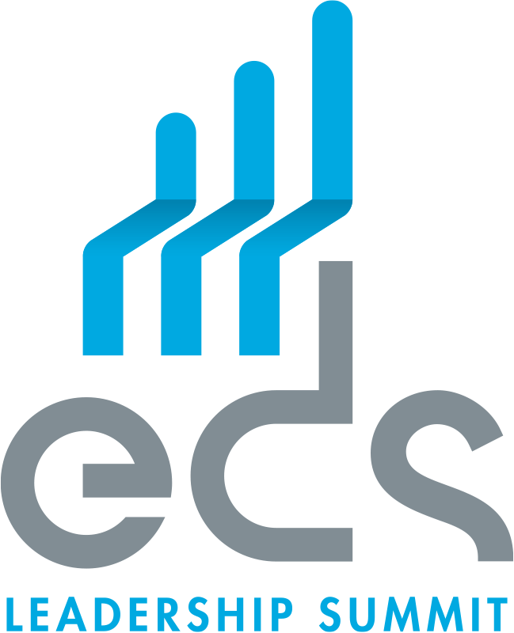

NEWS RELEASE
FOR IMMEDIATE RELEASE

Contact: Robin B. Gray, Jr.
Chief Operating Officer & General Counsel
Electronic Components Industry Association (ECIA)
rgray@ecianow.org

EDS cancels the 2020 EDS Leadership Summit,
scheduled for May 11-15 in Las Vegas.
Due to the ongoing Covid-19 outbreak, the electronics components industry’s premier event will next take place in 2021.

ALPHARETTA, GA, March 18th, 2020– The Electronic Distributors Summit (EDS) board of directors has announced today that its 2020 EDS Leadership Summit, scheduled to be held at the Mirage Resort in Las Vegas May 11-15, has been cancelled due to the rapidly evolving outbreak of the novel coronavirus (COVID-19). The next EDS will be held May 10-14, 2021, in Las Vegas at The Mirage Resort.
Considered the premier annual event for the international electronics components industry, EDS draws over 4,000 executives from world’s leading manufacturers, distributors and sales representatives. EDS is jointly sponsored by three major industry organizations: the Electronics Components Industry Association (ECIA), the Electronics Representatives Association (ERA) and the Global Electronic Distributors Association (GEDA).
“We’ve all been watching the fast-moving developments of the COVID-19 pandemic and we decided to be proactive for obvious reasons,” said EDS board member Robert Logan. “The most important aspect of this decision is the health and well-being of our fellow industry citizens. To that end, the board along with our sponsoring associations have decided to cancel EDS 2020.”
EDS will automatically refund individual registrations and registrations for the SPARK Professional Development Program. Sponsors and companies that have reserved meeting spaces can either request a full refund or apply their fees to the 2021 EDS. Mirage room reservations made directly with the Mirage within the EDS room block will be automatically cancelled and the first-night deposit will be credited back.
For more information, visit edssummit.com.

###

ABOUT THE EDS LEADERSHIP SUMMIT
EDS is the premier annual event for leaders and innovators in the international electronics industry. It brings together the manufacturers, distributors and representatives
of electronic components, instruments and accessories. It allows the brightest minds in the industry an opportunity to meet, make contacts and build their businesses. Suppliers of industry goods and services also are on hand to market their products.

The emphasis at EDS is on forging and maintaining business relationships through scheduled, one-on-one meetings. The event also offers important product exhibits, educational programming and networking opportunities. EDS is a combined effort and strongly supported by three of the industry’s leading member organizations — the Electronic Components Industry Association (ECIA), the Electronics Representatives Association International (ERA) and the Global Electronics Distributors Association (GEDA).

###
###

